From Oscar Statuettes To the World

**Written By Ketty**

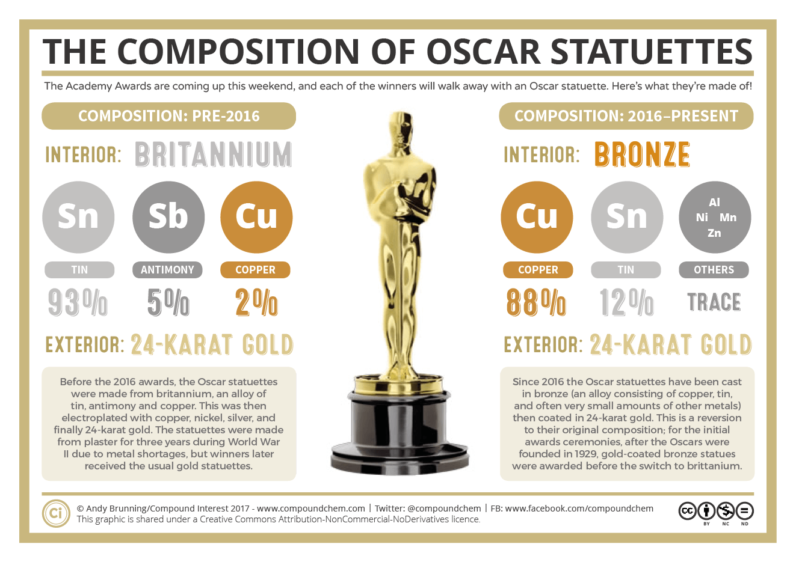

Since the nominees for the 90th Academy Awards were announced on January 23, 2018, more and more people started to pay attention to the award. Have you ever had a question is that why we always said how much the gold content the award has? Does every award really have gold in it? What can we find from those awards? Let’s use the Oscar Statuette as an example to discuss this topic.

“Oscar stands 13½ inches tall and weighs in at a robust 8½ pounds.”[1] This is the original design of Oscar Statuettes. The Oscar Statuettes are cast in bronze, an alloy consisting of copper (88%), tin (12%) , and often very small amounts of other metals, and then coated in 24-karat gold.[2]

In other words, only the surface of Oscar Statuettes is golden, the other parts of Statuettes are all made of alloy. However, why the Oscar Statuettes are mainly made of alloy? Maybe we can go to find some benefits of using alloy.

When we mix several metals, we will create a new type of metal which has new properties even has not existed. For example, Solder is an alloy of lead and tin. No matter lead or tin, their melting points are all higher than solder. This makes it great for producing conductive joints between electrical components.

Moreover, we all know that Iron is tough, but it is very easy to be corroded. “Chromium resists corrosion, but is very brittle. An alloy of iron with about 18% chromium (stainless steel) enjoys the toughness of iron and the corrosion resistance of chromium.”[3]

From these examples, we find that alloys are usually a very beneficial. However, in some cases, alloy also can be worse than the original metals. We have to look for the best alloy through trying.

Here is a simple introduction of how to make alloys: Firstly, put metals what you want to mix into the crucible onto a pipe clay triangle, and then molting them and stir with a spatula until the metals are both molten and thoroughly. Finally, we can put it into the cast and cool it down. Watch out, if you don’t deal with these steps well, the environment may be influenced negatively. [4]

Alloys are very widely used in our lives. As one of the most vastly used alloys, the stainless steel alloy is used in application at the bottom of the sea. “Commercial applications of these alloys include cutleries and watch straps. In the manufacturing industry, stainless steel alloys are used to make electronic agricultural materials.”[5]

Bonus:

1. Summarize this article in one to two simple paragraphs.
2. Give an example of the alloy which has worse properties than the original metals.
3. Do you think alloy will replace metals completely in the future?
4. If making alloys has some disadvantages, please list them. If possible, thinking of some methods to try to solve these questions.
5. What tips can creating alloy bring for us to study chemistry?

Work Cited Page

[1] “OSCAR STATUETTE” [oscars.org,](http://www.oscars.org/oscars/statuette) 2015

[2] Compound Interest. “The Composition of Oscar Statuettes” [compoundchem.com](http://www.compoundchem.com/2017/02/25/oscars/), February 25th, 2017

[3] Bill Thacker. “What are the advantages of using alloys over other metals?” [quora.com](https://www.quora.com/What-are-the-advantages-of-using-alloys-over-other-metals), May 22, 2016

[4]http://www.rsc.org/Education/Teachers/Resources/Inspirational/resources/2.3.1.pdf

[5] Anonymous. “Uses of Alloys” thegreenbook.com, 3/23/2015